1. Which product has the highest price? Only return a single row.

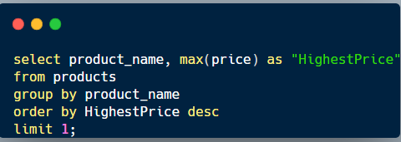

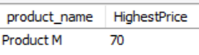

1. Which customer has made the most orders?

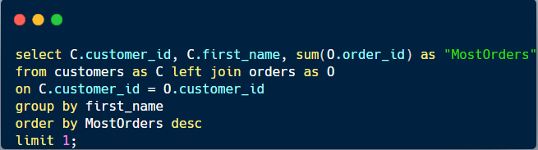 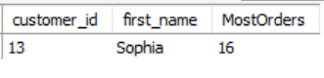

1. What’s the total revenue per product?

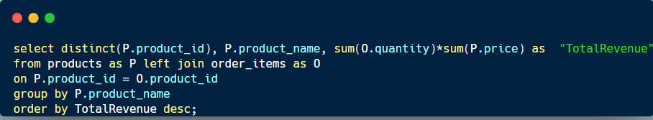 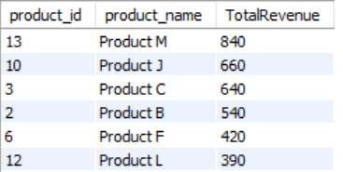

1. Find the day with the highest revenue.

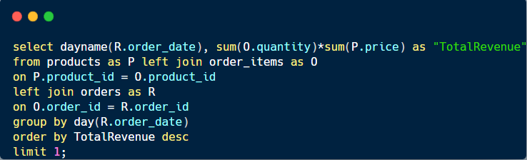 

1. Find the first order (by date) for each customer.

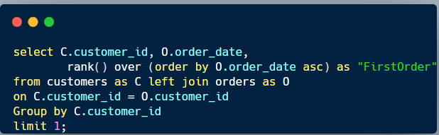 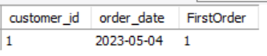

1. Find the top 3 customers who have ordered the most distinct products

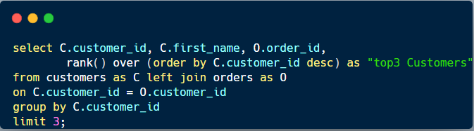 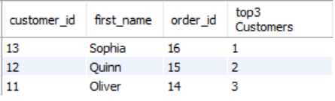

1. Which product has been bought the least in terms of quantity?

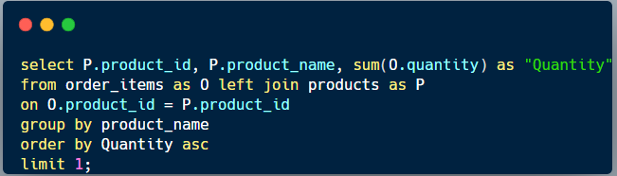 

1. For each order, determine if it was ‘Expensive’ (total over 300), ‘Affordable’ (total over 100), or ‘Cheap’.

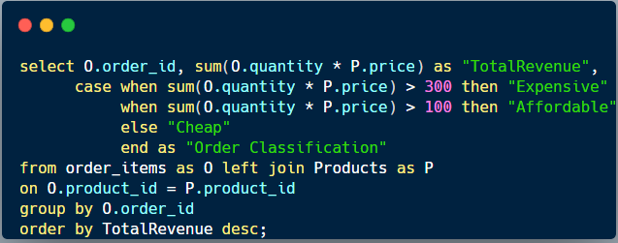 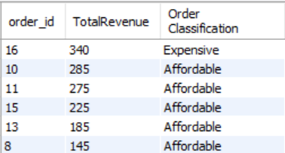

1. Find customers who have ordered the product with the highest price.

